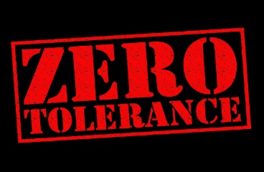
INSERT COMPANY LOGO

SAMPLE (Organization Name Here) Zero Tolerance Policy for Inappropriate Behaviors

Contents
(Insert Organization Name Here) is committed to providing a safe environment for all participants, staff and volunteers. Therefore, it shall be established that our organization will have Zero Tolerance of any and all inappropriate behaviors of any staff, volunteers and/or participants (Including Family and Family Friends) occurring both on our premises and off. (Insert Organization Name Here) will hold everyone’s safety as top priority and will strive to maintain this priority by holding all staff, volunteers and participants accountable to this policy and the procedures established in the Abuse & Neglect Prevention Plan. In addition, every allegation of inappropriate behavior will be handled in accordance with the established procedure for “Responding to Allegation” as found within the organizational written Abuse & Neglect Prevention Plan.

In accordance with local, state and federal laws, (Insert Organization Name Here) shall cooperate with all law enforcement officials, without delay, to the fullest extent possible when responding to any allegation of inappropriate behavior occurring both on our premises and off.

We are 100% committed to the safety of everyone as a core value in support of our organizational mission and purpose. We recognize that we cannot fulfill our organizational mission without maintaining a safe environment and culture. Because of this, we will hold this core value as top priority in all operational areas/divisions of the organization.

_________________________________________
Signature of the CEO/President

Bandwidth of Acceptable Behaviors

Unacceptable (DON’T)

Wrestling

Piggyback

Kisses

Lap sitting

Full frontal hugs

Tickling

Allow youth to cling to staff’s or volunteer’s leg

Any type of massage given by or to a youth

Any form of affection that is unwanted by the youth/staff
Showing affection in isolated areas

Compliments relating to physique or body development

Touching bottom, chest and/or genital area

Acceptable (DO)

Arms around shoulders

Touching hands, shoulders and arms

Side hugs

Verbal praise
Shoulder to shoulder or “temple” hugs

Holding hands (with young children in escorting situations)

Pats on shoulder or back

Pats on head when culturally appropriate

High fives and hand slapping

Touching hands, shoulders and arms

_____________________________________
Print Name

_____________________________________ _____________________________________
Signature Human Resources Representative

